**MIDDLETON CHENEY FOOTBALL CLUB**

**ANNUAL GENERAL MEETING**

**1996**

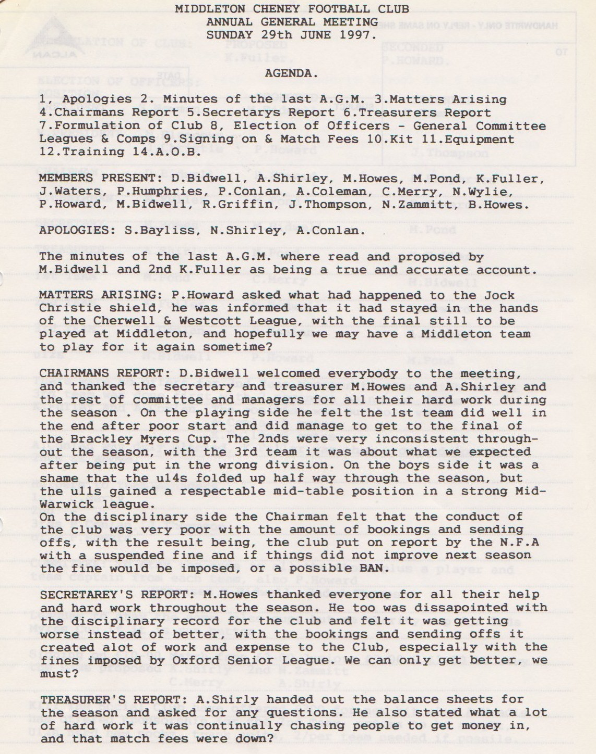

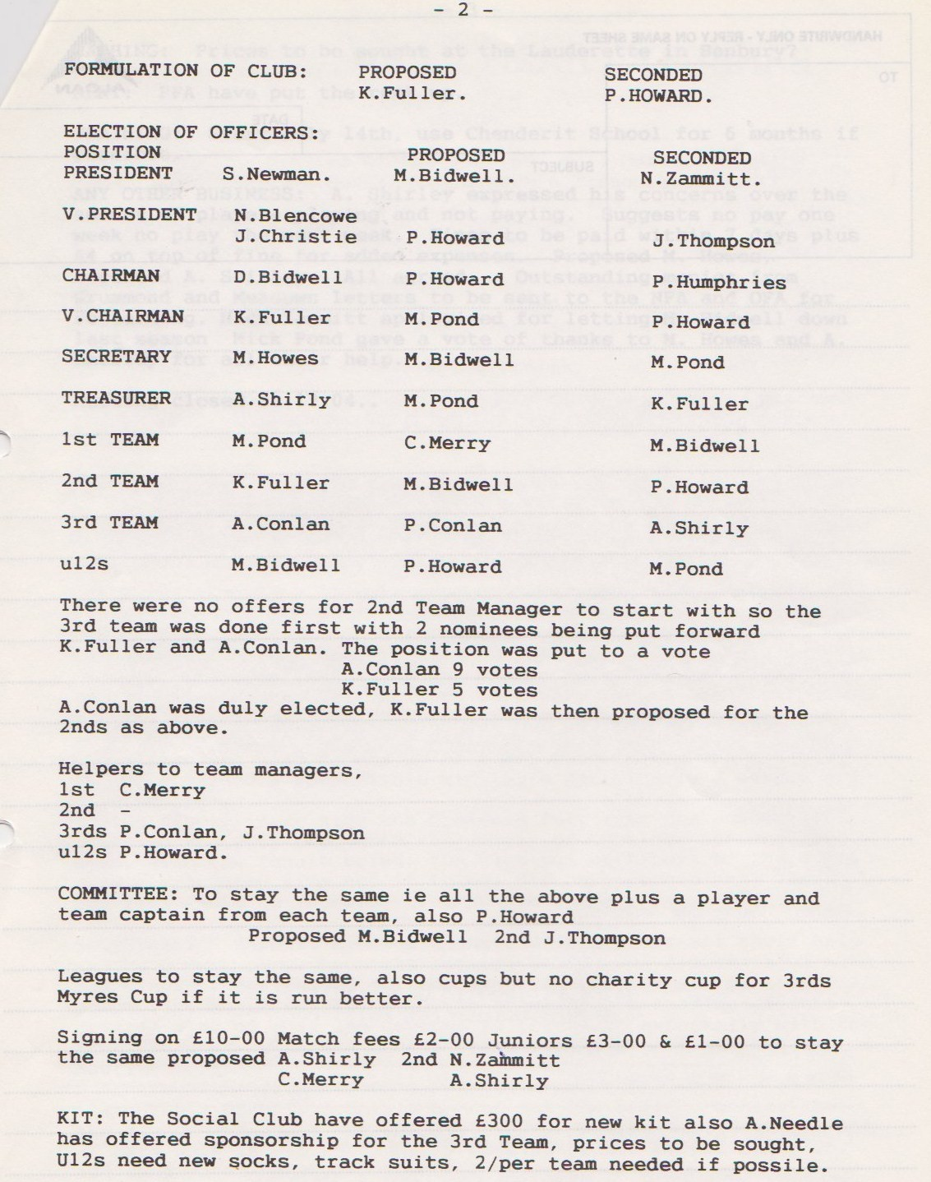

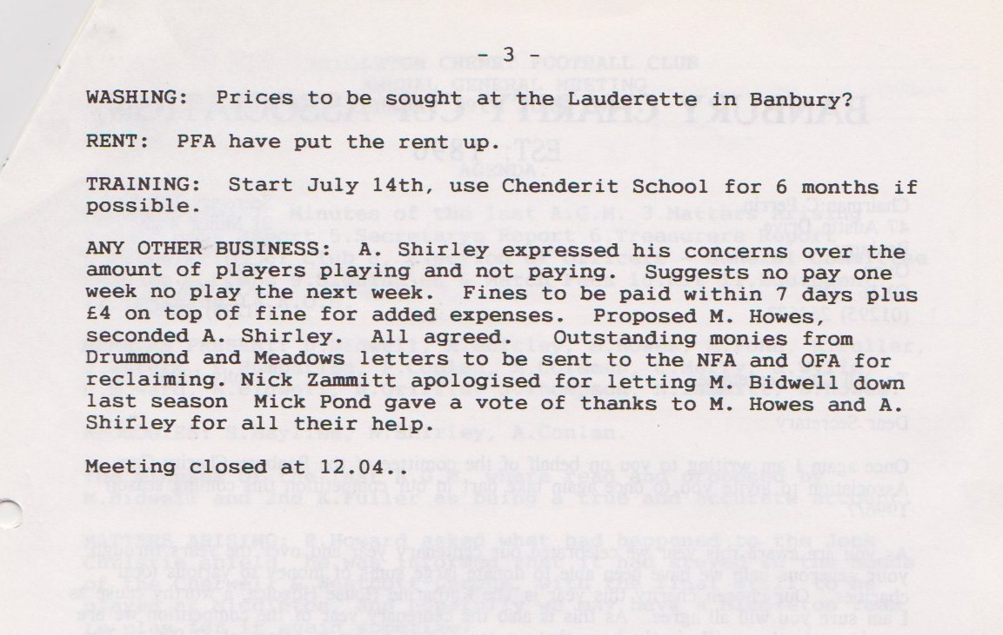

**General Committee Meeting**

**September 7th 1996**

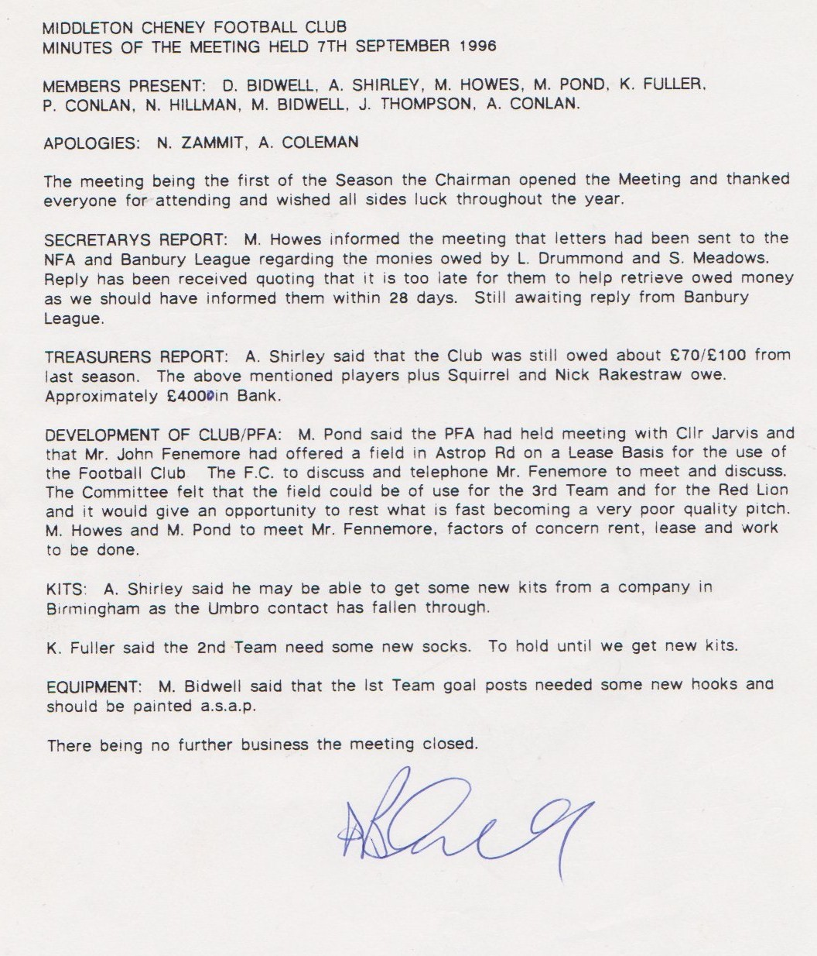

**General Committee Meeting**

**October 5th 1996**

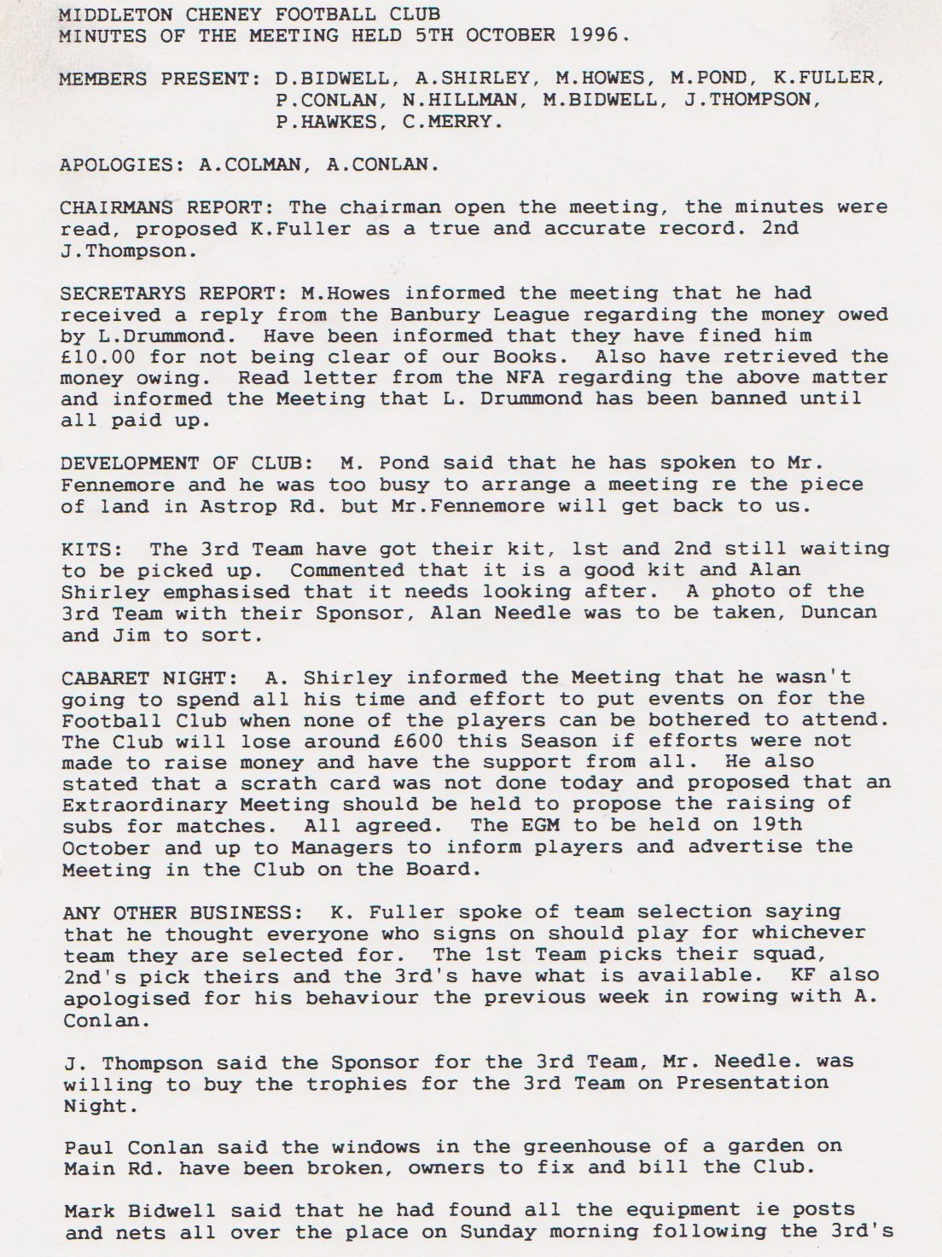

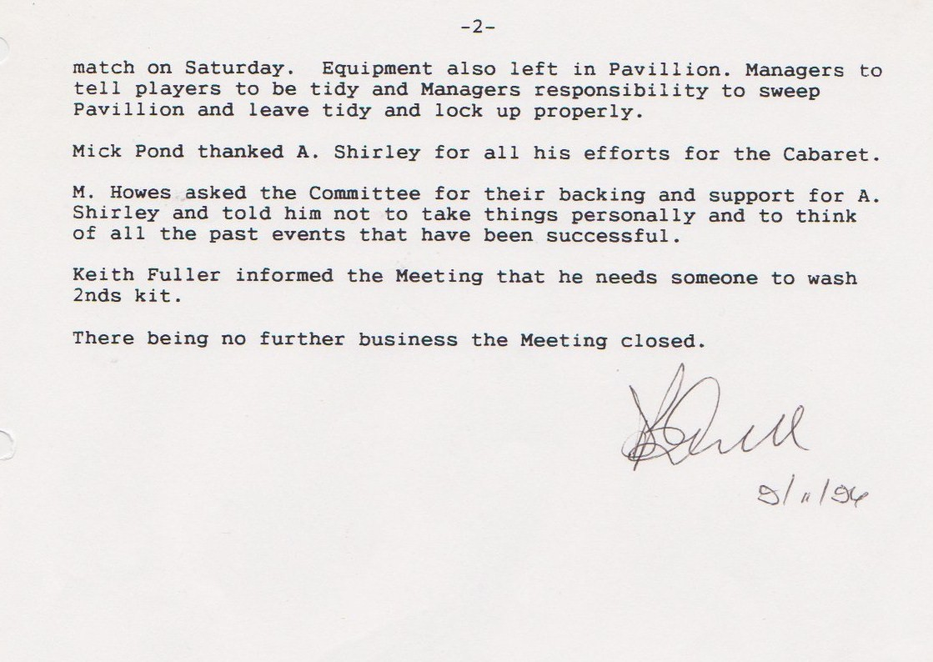

**General Committee Meeting**

**March 1st 1997**

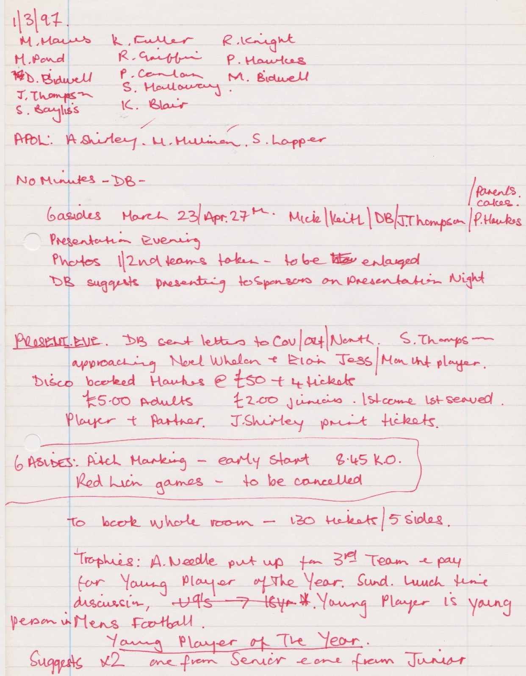

**Continued**

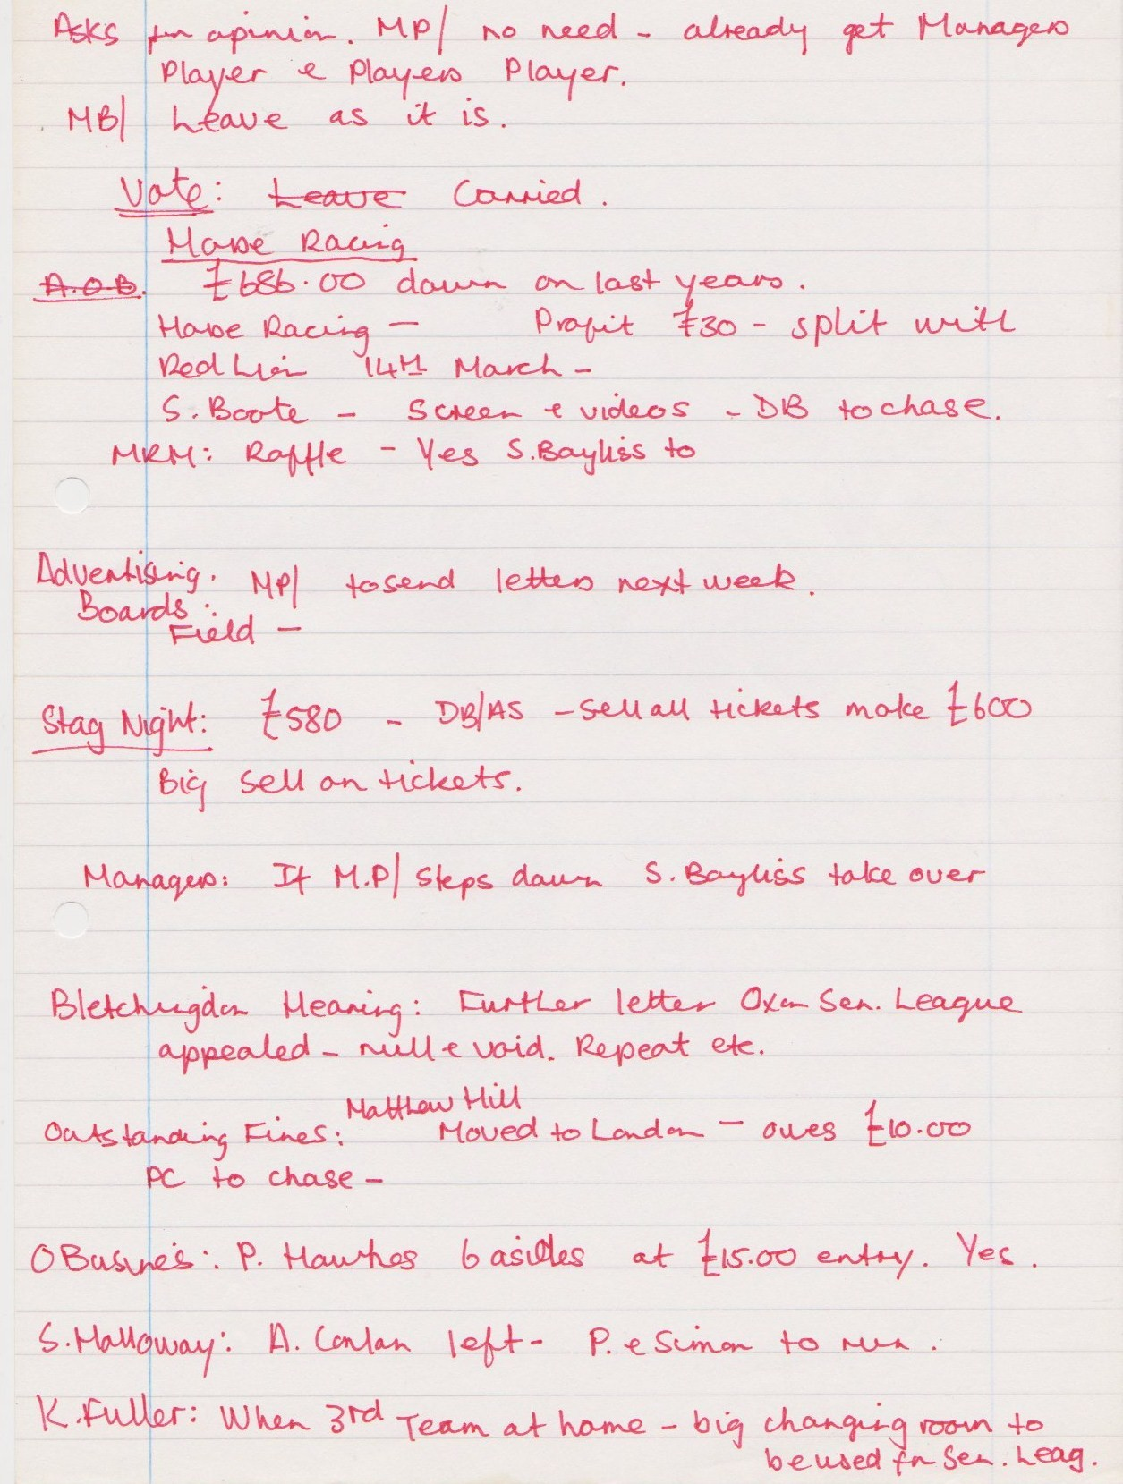

**Continued**

